Minor Project Synopsis Report
Ikaros: The Saviour of Seven Lands
Project Category: Research/Industry/Start-up/University Based Project/ Deep-tech/ IoT Based
Projexa Team Id- 26E2081

Submitted in partial fulfilment of the requirement of the degree of
BACHELORS OF TECHNOLOGY
in
CSE with Specialization UI/UX(Section -A)
to
K.R Mangalam University
by
VISHESH VINSHAN SARASWAT (2401360027)

PARNEET KAUR (2401360010)

VANSH LUTHAR (2401360017)

ANUSHIKA SINGH (2401360015)

AKSHAT ARYA (2401360005)

Under the supervision of

Supervisor Name: Ms. Swati Jain Kansal



Department of Computer Science and Engineering School of Engineering and Technology
K.R Mangalam University, Gurugram- 122001, India January 2026

INDEX

1. | Abstract | Page No.
2. | Introduction (description of broad topic)
3. | Motivation
4. | Literature Review
5. | Gap Analysis
6. | Problem Statement
7. | Objectives
8. | Tools/platform Used
9. | Methodology
10. | References

1. ABSTRACT

The rapid evolution of game development technologies has enabled the creation of immersive, interactive, and visually engaging digital environments that enhance player experience and storytelling. Ikaros: The Saviour of Seven Lands is an action-adventure fantasy game developed as a minor project with the objective of creating an engaging virtual world where players take on the role of a heroic character, Ikaros, who must restore peace and balance across seven distinct lands threatened by dark forces. Each land is uniquely designed with different environments, obstacles, and enemies, encouraging players to explore, make strategic decisions, and progress through multiple levels. The game is developed using the Unity game engine by Unity Technologies and programmed using C#, incorporating essential game development elements such as character control, enemy AI, collision detection, health management, animations, and interactive user interfaces. The system focuses on delivering smooth gameplay, engaging visuals, and an intuitive user experience to ensure players remain immersed in the game environment.

The main point of this project is to demonstrate the practical implementation of game development concepts, including object-oriented programming, game design, user interface design, and interactive storytelling, while creating an entertaining and functional fantasy game. This project also highlights the importance of creativity, technical skills, and logical thinking in modern software and game development, and showcases how interactive games can serve as powerful tools for learning, entertainment, and innovation.

Keywords: Game Development, Unity, C#, Action-Adventure Game, Interactive Design, User Experience, Fantasy Game

2. INTRODUCTION

With the rapid growth of digital technology, video games have become one of the most popular forms of entertainment and interactive media. Modern games provide immersive environments that allow players to explore virtual worlds, complete missions, and overcome challenges. Fantasy and action-adventure games, in particular, enhance skills such as problem-solving, strategic thinking, and decision-making. The development of such games involves the use of advanced tools, programming languages, and game engines to create realistic characters, smooth animations, and engaging user interfaces.

Ikaros: The Saviour of Seven Lands is an action-adventure fantasy game developed using the Unity game engine by Unity Technologies and programmed in C#. In this game, the player controls the hero Ikaros, whose mission is to restore peace across seven unique lands filled with enemies and obstacles. Each level presents new challenges that encourage exploration and strategic gameplay.

The main objective of this project is to demonstrate the practical implementation of game development concepts such as programming, character control, level design, and user interface while creating an engaging and interactive gaming experience.

3. MOTIVATION

With the rapid advancement of digital technology and the increasing popularity of video games, game development has become an important field that combines creativity, programming, and interactive design. Modern players expect games to provide immersive environments, engaging storylines, and interactive gameplay that keeps them motivated and entertained. Fantasy and action-adventure games are especially popular because they allow players to explore imaginative worlds, face challenges, defeat enemies, and achieve goals. Developing such games provides an excellent opportunity to apply programming knowledge, logical thinking, and creative design skills while understanding how real-world software applications are built.

The motivation behind developing Ikaros: The Saviour of Seven Lands is to create an interactive fantasy game that demonstrates the practical implementation of game development concepts using the Unity game engine by Unity Technologies and C#. The game focuses on controlling the hero, Ikaros, who must travel across seven different lands, each with unique environments, enemies, and obstacles.

The main goal of this project is to design and develop a functional and engaging game that applies concepts such as character movement, enemy interaction, level progression, animation, and user interface design while providing an immersive and enjoyable experience to the player. This project also helps in improving technical skills, creativity, and understanding of modern game development processes.

4. LITERATURE REVIEW

In recent years, video game development has gained significant attention as an important field combining creativity, programming, and interactive technology. Several studies highlight that well-designed video games enhance player engagement by providing immersive environments, clear objectives, and interactive gameplay mechanics. Researchers emphasize that effective game design involves the integration of character control, level progression, reward systems, and visual feedback to maintain player motivation and interest. The use of modern game engines such as the Unity engine by Unity Technologies has made it easier for developers to create high-quality games with realistic graphics, animations, and smooth performance.

Existing literature on game development reveals that traditional games were limited in terms of interactivity, graphics, and gameplay complexity due to hardware and software constraints. However, modern tools and technologies have enabled developers to create dynamic and responsive gaming environments. Studies show that implementing object-oriented programming concepts improves code organization, reusability, and scalability in game development. Features such as character movement, collision detection, enemy behaviour, and health systems are essential components that contribute to a functional and engaging game experience.

Several researchers have also emphasized the importance of user interface (UI) and user experience (UX) design in games. A well-designed interface allows players to easily interact with the game, understand objectives, and navigate through different levels. Visual elements such as animations, sound effects, and environmental design enhance immersion and improve overall gameplay quality. Literature suggests that level design plays a crucial role in maintaining player interest by introducing new challenges, obstacles, and rewards as the player progresses.
Studies related to artificial intelligence in games highlight its importance in creating intelligent and responsive enemy behaviour.

AI-controlled enemies can react to player actions, increasing the difficulty level and making the gameplay more engaging and realistic. Researchers also note that structured level progression and storytelling improve player immersion and emotional connection with the game. These elements help in creating a meaningful and enjoyable gaming experience.

Further research highlights that modern game engines provide integrated tools for physics simulation, animation, and scripting, which simplify the game development process. These tools enable developers to focus on creativity and gameplay design while ensuring technical efficiency. However, literature also identifies challenges such as performance optimization, debugging, and balancing game difficulty to ensure smooth gameplay across different systems.

Despite these advancements, there is still a need for developing games that effectively combine programming concepts, interactive design, and engaging storytelling.

This project builds upon existing research by developing Ikaros: The Saviour of Seven Lands, an action-adventure fantasy game that focuses on immersive gameplay, character interaction, level progression, and user-friendly design. The project demonstrates the practical implementation of game development concepts while creating an enjoyable and interactive gaming experience.

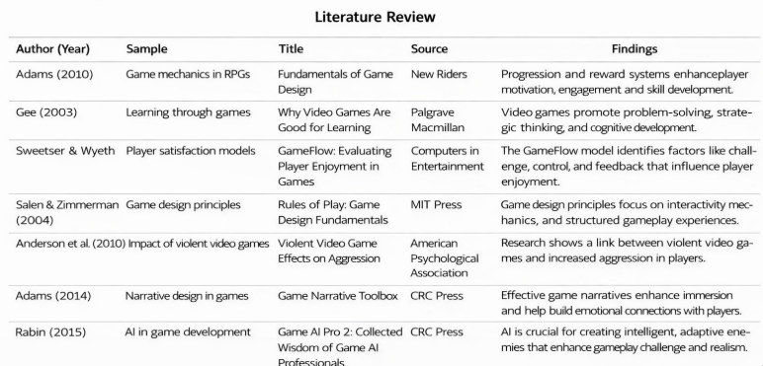

5. GAP ANALYSIS

From the numerous studies conducted in the field of video game development, it is evident that modern games have significantly improved in terms of graphics, gameplay mechanics, artificial intelligence, and user interaction compared to traditional games. Many existing projects focus on individual aspects such as character movement, visual design, or basic level creation. However, several games lack a complete integration of essential components such as structured level progression, intelligent enemy behaviour, interactive environments, and user-friendly interface design within a single system. Some projects also do not fully utilize object-oriented programming concepts and modern game engines, which limits scalability, performance, and overall gameplay experience.

Additionally, many academic and student-level game projects focus primarily on visual appearance rather than balanced gameplay mechanics and player engagement. Features such as smooth character control, proper collision detection, health systems, enemy interaction, and immersive storytelling are sometimes missing or not properly implemented. This creates a gap between basic game prototypes and fully functional interactive games that provide a complete and enjoyable user experience.
Our project, Ikaros: The Saviour of Seven Lands, addresses these limitations by developing a comprehensive action-adventure fantasy game using the Unity game engine by Unity Technologies and C#.

The game integrates essential features such as character movement, enemy interaction, level progression, animation, and user-friendly interface design within a single platform.

This project provides a complete and functional game environment that demonstrates the practical implementation of programming concepts, game design principles, and interactive storytelling.

By combining technical implementation with creative design, the project delivers an engaging and immersive gaming experience while bridging the gaps identified in existing game development projects.

6. PROBLEM STATEMENT

Ikaros: The Savior of Seven Lands is an educational, story-driven adventure game designed to teach players about different world cultures and traditions through immersive gameplay. Unlike conventional games that focus only on entertainment, this project integrates cultural learning with interactive storytelling. Each of the seven lands in the game is inspired by a distinct real-world culture, reflecting its traditions, mythology, architecture, values, and social practices. Players assume the role of Ikaros, a hero tasked with restoring harmony across the seven lands. As players progress, they learn about cultural diversity through quests, dialogues, rituals, and moral choices embedded naturally into the gameplay. The game aims to make cultural education engaging, memorable, and accessible for a wide audience, especially students and young learners

7. OBJECTIVES

- To create an educational game that promotes awareness of global cultures and traditions.
- To teach cultural values and history through immersive storytelling and gameplay.
- To encourage curiosity, empathy, and respect for cultural diversity.
- To provide an interactive learning alternative to traditional educational methods.
- To combine entertainment and education in a meaningful and engaging manner.

The objective of this project is to overcome the limitations of basic game development projects and to create an interactive and immersive action-adventure fantasy game, Ikaros: The Saviour of Seven Lands. The game is designed to provide an engaging experience where players can control the main character, explore different lands, overcome obstacles, and defeat enemies while progressing through multiple levels. The project focuses on implementing essential game development features such as character movement, collision detection, enemy interaction, health systems, animations, and level progression.

8. Tools/Technologies Used

For this project, various modern tools and technologies have been used to develop an interactive and immersive action-adventure fantasy game, Ikaros: The Saviour of Seven Lands. These technologies help in creating engaging gameplay, smooth character movement, realistic animations, and an intuitive user interface. The following programming language and game engine were used for the development of this project.

PROGRAMMING LANGUAGE: C#
C# is a modern, object-oriented programming language developed by Microsoft and is widely used for game development, especially with the Unity game engine by Unity Technologies. It provides powerful features that allow developers to control game logic, character movement, enemy behavior, collision detection, animations, and user interface elements. C# is easy to learn, efficient, and highly suitable for developing scalable and interactive games.
C# was designed with a focus on simplicity, performance, and code reusability. It supports object-oriented programming concepts such as classes, objects, inheritance, and polymorphism, which are essential for structured and modular game development. Using C#, developers can efficiently manage game components, implement gameplay mechanics, and ensure smooth interaction between different elements of the game.

Reasons for Selecting this Language:
- Object-Oriented Programming support for structured game development.
- Easy integration with the Unity game engine.
- Simple and readable syntax.
- Provides high performance and efficient memory management.
- Large community support and extensive documentation.
- Widely used industry-standard language for game development.

9.METHODOLOGY

1. GAME DEVELOPMENT PROCESS – UNITY ENGINE USED
This project is developed using the Unity game engine, which provides a real-time interactive environment for building cross-platform games. The game is designed to provide an engaging and educational experience where users identify cuisines belonging to different countries.
The system continuously processes user inputs and displays interactive elements such as food images, options, and feedback. The game logic checks whether the selected answer is correct or incorrect and updates the score accordingly. If the answer is correct, the score increases; otherwise, feedback is given to the player.

2. USER INTERFACE (UI/UX) DESIGN MODULE
The UI/UX of the game is designed to ensure smooth navigation and user-friendly interaction. The interface includes:
- Start Screen
- Level Selection Screen
- Gameplay Screen
- Score/Result Screen
The design focuses on clarity, minimalism, and accessibility. Buttons, icons, and layouts are structured to provide a seamless user experience.
The layout follows a structured design where elements are placed using grids and alignment principles to maintain consistency across screens.

3. AUDIO & FEEDBACK SYSTEM
The game integrates audio elements to enhance user engagement. Different sounds are used for:
- Correct Answer
- Wrong Answer
- Button Clicks
- Background Music
This helps in improving the overall experience and makes the game more interactive.

4. BLIND MODE FUNCTIONALITY
A special feature of the game is the Blind Mode, designed for accessibility.
In this mode:
- Audio instructions guide the player
- Options are read aloud
- Users can interact using sound cues instead of visuals
This ensures inclusivity and allows visually impaired users to play the game effectively.

5. GAME LOGIC & DATA HANDLING
The game follows a structured logic system:
- Questions are stored in a predefined dataset
- Each question contains:
  - Food Item
  - Multiple Options
  - Correct Answer
The system randomly selects questions and displays them to the player. After each response, the system evaluates the answer and updates the game state.

6. SCORE & PROGRESSION SYSTEM
The scoring system tracks player performance:
- Correct answer → Score increment
- Wrong answer → No increment
At the end of the game:
- Final score is displayed
- Performance feedback is provided
This encourages users to improve and replay the game.

7. FLOW OF THE SYSTEM
The working of the system follows these steps:
- User starts the game
- Game loads the question dataset
- Question is displayed on screen
- User selects an option
- System checks correctness
- Score is updated
- Next question is loaded
- Final result is displayed

8. TECHNOLOGIES USED
- Unity Engine
- C# Programming Language
- UI Design Tools (Figma / Unity UI System)
- Audio Integration Tools

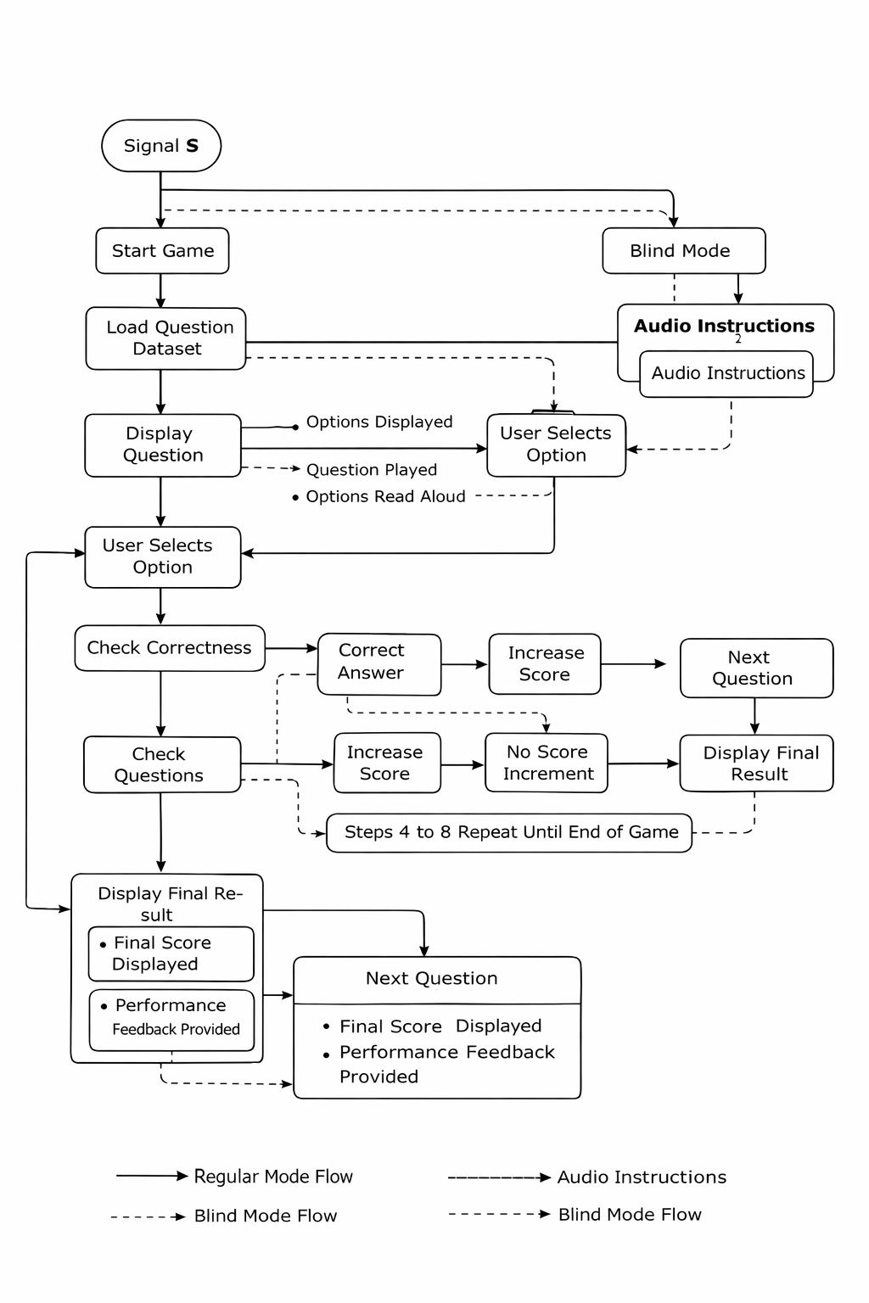
10. References
Unity Official Documentation
Microsoft C# Documentation
Figma Official Website
Unity UI System Guide
Google Text-to-Speech Overview

THANK YOU

